**Software Engineering**

Books or notes are **not** allowed.

Write only on these sheets. **Concise** and **readable** answers please.

Surname, name, matricola _________________________________________________

*Bicycle race management*

Races, and in particular bicycle races, are supported by dedicated software applications.

Before the race every participant must enroll, providing an ID, and medical documents to prove fitness for the race. The organization gives to the participant an RFID chip and a race number. The participant also pays a fee, that can depend on the category of the participant (ex senior, junior etc).

Assume that this first step happens in an office of the organization, where the organization accesses the application via a PC.

Before the race the organization can show (on the race web site) the list of participants and the start order (participants start at different times in function of their category).

Further, via the application the organization defines the geographical path of the race, and publishes it on the web site. Participants can also download the path as a GPS trace (kmz or gpx file).

Before the start of the race, the organization sets dedicated RFID readers at the start and finish point of the race (and possibly in intermediate points). The readers read the RFID chip of each participant when it passes close, and sends (via cellular network) the times to the application.

During, and especially at the end of the race, the organization publishes the current and final ranking of the participants.

In the following you should analyze and model an application to support the above listed functions. The application is in fact a system that comprises also the RFID readers.

1 – a. Define the **context diagram** (including relevant interfaces- remember this must be consistent with System design requested later in 1-f )

|  |  |  |
| --- | --- | --- |
| Actor | Physical interface | Logical interface |
| Participant | Screen / keyboard on PC or smartphone | GUI |
| Organization staff | Screen / keyboard on PC | GUI |
| RFID chip | Radio frequency | Read ID |

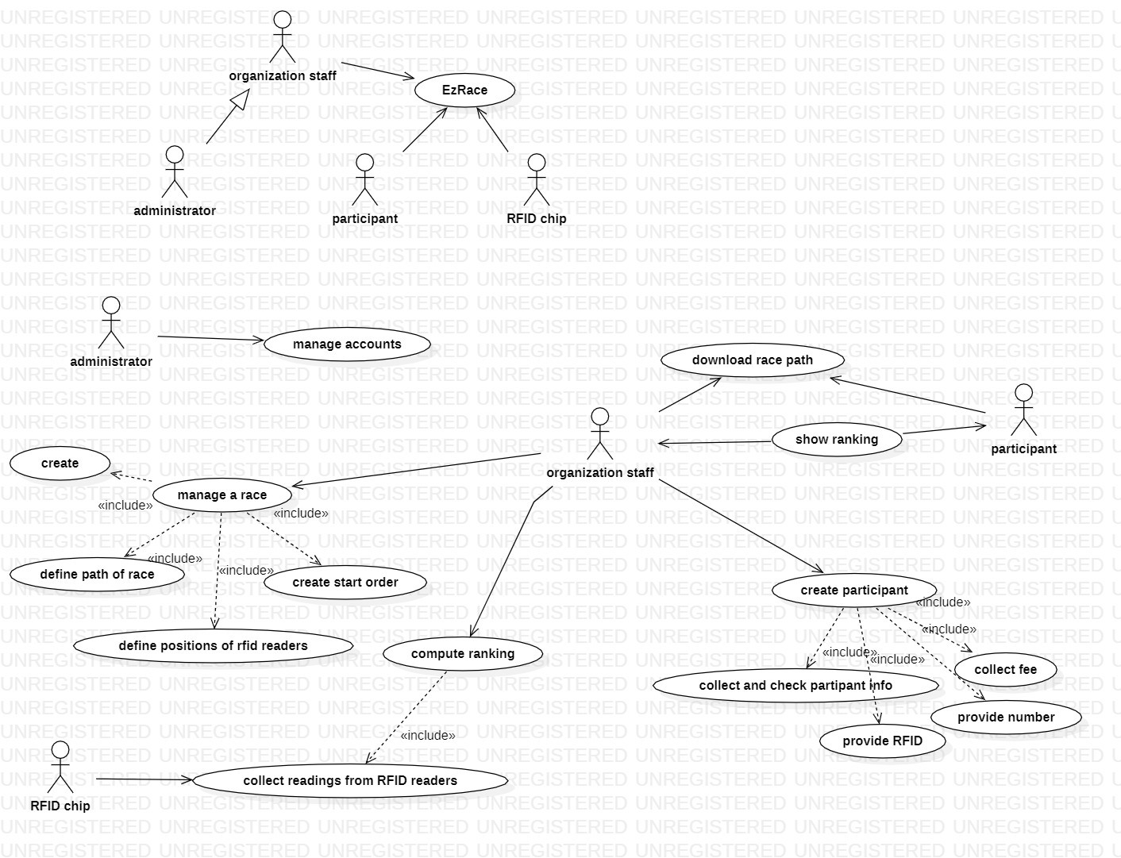

1-b Define the **glossary** (key concepts and their relationships) (UML class diagram) for the application

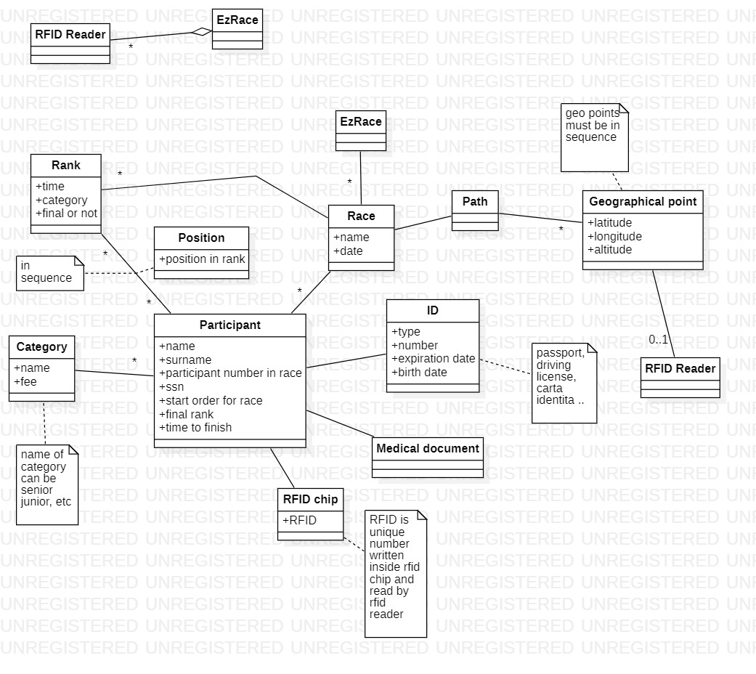

1-c Draw the Use Case Diagram for the application. For each Use Case give self-explainable long names, or a short textual description



Deployment diagram

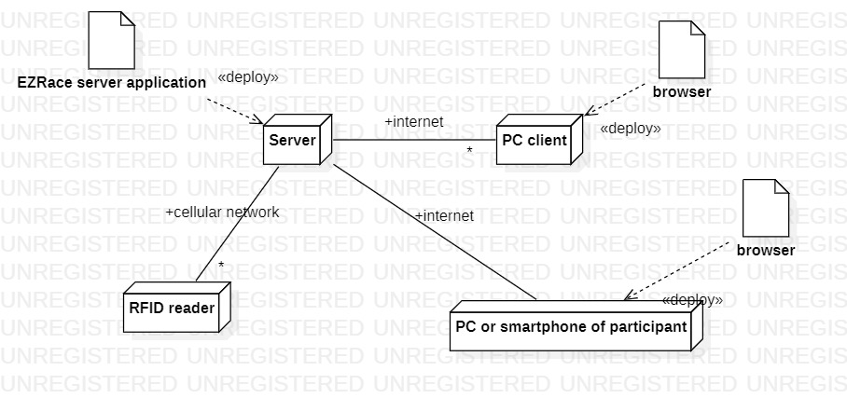

System design

